Name: __________________________

MA 101 – QUIZ #3A
CHAPTER THREE – FINITE MATHEMATICS

Part 1 – Circle the best answer

- If the reciprocal of 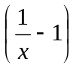is –2, then x equals
(a) -1 (b) 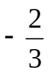 (c)  (d)  (e) 2
- If 630 is expressed as the product of three positive integers whose sum is 38, then the largest of these integers is
(a) 35 (b) 30 (c) 21 (d) 18 (e) 15
- If  of a number is 60, then  of the original number is
(a) 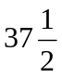 (b) 45 (c) 54 (d) 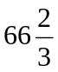 (e) 72
- If 3x + 7 = x² + k = 7x + 15, then k equals
(a) -45 (b) -3 (c) -2 (d) 2 (e) 25

Part II – Problems (2 marks each). Sketch a graph for each question.

- Find the equation of a line passing through (-3,1) and (2,3)
y
x
- Find the equation of a line parallel to 2y – x = 6 and passing through (2,1)
y
y
x
- Solve the system
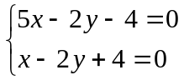
x

